Midterm Project
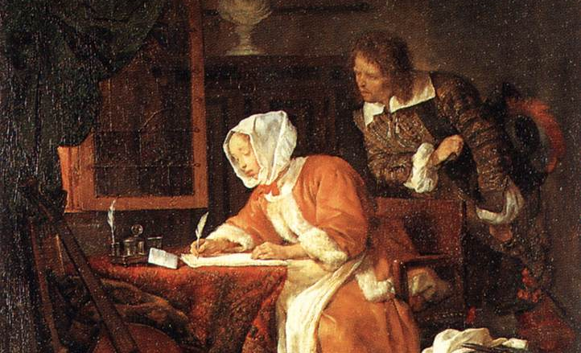
Because the literary establishment has been dominated by men, and women’s contributions to literature were generally viewed askance, the definition of “literature” has been shaped by sexist assumptions about the role of women in relating the human experience.

Research one variety of writing women have done that has been excluded from the category of “literature,” collect examples of this from a variety of historical and national contexts, discuss why it was excluded, and make an argument for its inclusion alongside of traditional literary forms.
Assignment Goals

- Apply skills of close reading and analysis to the texts in this course,
- Demonstrate how the literary texts in this course both shape and are shaped by their historical, cultural, and intertextual contexts,
- Conduct independent literary (and other types of) research, using appropriate resources and technologies,

Purpose
- To think carefully about the ways that women have historically contributed to the written world,
- To analyze the ways in which their contributions have been marginalized,
- To develop a sense of “literature” as a constructed category, alongside of “gender” and “sex”
- Recount the history of women's contributions to literature and argue about how those contributions, and literature, have been shaped by the construction of “the woman,”
Basics

- 1500 original words (not including samples)
- Provides at least 5 (and no more than 10) samples of this type of writing/communication
- Samples should be either originals or scans/copies of originals
- Close reading of the language/images used in the texts
- Well-developed connections between forms of writing that are “not literature” and contemporary literature by women

Organization

- Discusses definitions of literature, including those remarked on in class as well as research on “literature” and “the canon”
- Identifies a historical or contemporary category of writing engaged in by women that has been excluded from the category of “literature,”
- Explains what stylistic or thematic elements might have contributed to this category’s exclusion, as well as social and historical pressures that may have influenced popular perceptions of this type of writing/communication
- Conducts a close reading of at least two of the 5-10 samples,
- Explains how this type of writing/communication can be understood as literature, drawing parallels with women’s writing we have discussed in class, as well as drawing parallels beyond class
- Develops an argument from the definitional negotiation, the historical contextualization, the close reading, and the conversation between the new category and the existing literature that effectively asserts the place of the new category alongside of more traditional literary forms

Possible topics include
- Recipes
- PTA meetings/book clubs/similar gatherings (that produce writing in some form)
- Letters
- Advice columns
- Diet fads
- Self-improvement groups
- Etiquette books
- Women’s magazines (fashion, housekeeping, etc.)
- Scrapbooks/albums

