Research on Social Justice Issue and Presentation
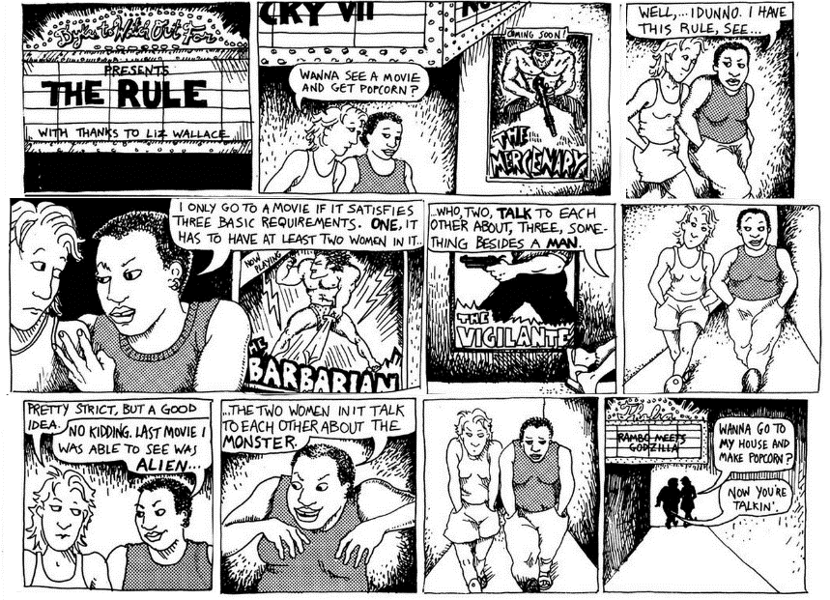
Goals
- Apply skills of close reading and analysis to the texts in this course,
- Demonstrate how the literary texts in this course both shape and are shaped by their historical, cultural, and intertextual contexts,
- Conduct independent literary research, using appropriate resources and technologies,
- Create an effective oral presentation of literature / literary research.

Basics
- 15% of overall grade
- use material from one (or two) of the novels, conducting a short close reading for the class of two passages in terms of how they relate to the issue and/or attitudes associated with it
- draw from at least three different fields. Literature and literary theory, of course, but you can also choose to use ideas from psychology, sociology, biology, history, law, etc.
- present basic facts (statistics about) the issue
- illustrate various stakeholders, their points of view, their motivations and ideologies
- develop a cogent argument based on a conversation between different sources

Parameters and Organization
- 15 minutes
- Working from note cards, visual aids, and memory
- Introduce the topic
- Develop a close reading of a portion of a novel that highlights this issue.
- Discuss the history of this topic, tracing an intellectual genealogy of how people have approached it
- Discuss the contemporary stakeholders, providing an analysis of their opinions and motivations
- Discuss how one or more novels from our class can illuminate some aspect of this issue.

Topics
Possible topics include (but are not limited to):
- Issues relating to intersectionality (women’s experiences of racism, homophobia, ableism, antisemitism, fatism, classism, xenophobia, ageism, etc.)
- Issues relating to healthcare and reproductive justice (birth control, maternity care, abortion, infant and/or maternal mortality, etc.)
- Issues relating to body policing and/or body dysmorphia (anorexia, bulimia, compulsive over-eating, media effects, etc.)
- Issues relating to romantic relationships (expectations regarding gender roles, the leisure gap, “lean in,” domestic violence, marriage law, etc.)

